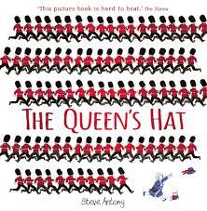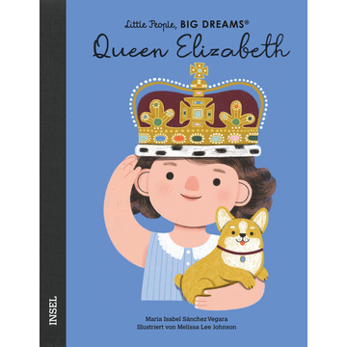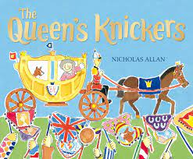

[**The Queens Knickers**](https://www.youtube.com/watch?v=ThVWW_RrMEk)

[The Queen's Hat](https://www.youtube.com/watch?v=OdwKj_waksg%20%20%20%20%20%20%20%20%20%20%20%20%20%20%20%20%20%20%20%20%20%20%20%20%20%20%20%20%20%20%20%20%20%20%20%20%20%20%20%20%20%20%20%20%20%20%20%20%20%20%20%20%20%20%20%20%20%20%20%20%20%20%20%20%20%20%20%20%20%20%20%20%20%20%20) 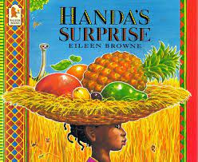

Stories and video links to support this terms learning

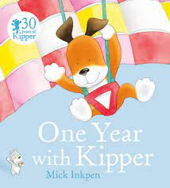 [Wave](https://www.youtube.com/watch?v=1yGFB83LP6c)

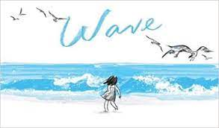[Handa's Surprise](https://www.youtube.com/watch?v=UrANbAjnQgM)

[One year with Kipper](https://www.youtube.com/watch?v=D5FB7wiW1MM%20%20%20%20%20%20%20%20%20%20%20%20%20%20%20%20%20%20%20%20%20%20%20%20%20%20%20%20%20%20%20%20%20%20%20%20%20%20%20%20%20%20%20%20%20%20%20%20%20%20%20%20%20%20%20%20%20%20%20%20%20%20%20%20%20%20%20%20%20%20%20%20%20%20%20%20%20%20%20%20%20%20%20%20%20%20%20%20%20)

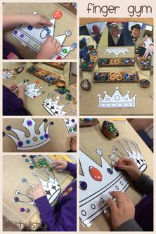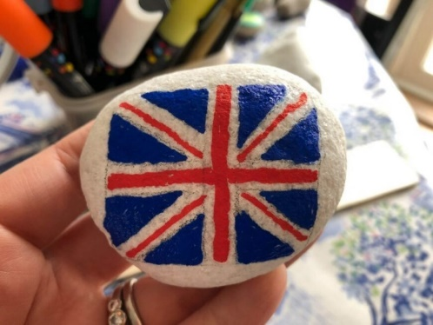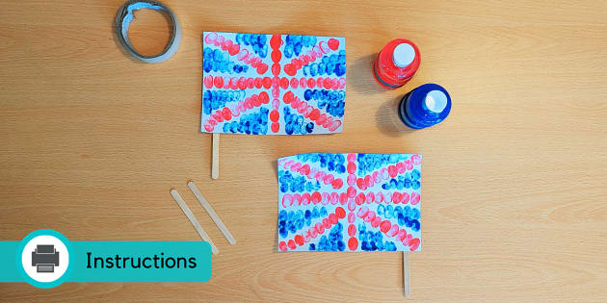

Speech Development- This week we will have a focus of talking about the jubilee celebrations we have seen so far.

We will be planning our own party in school this week, discussing all the things we need to organise and make. We will be writing lists of everything we need to do.

We will have a very creative week, making flags, bunting, paintings of the queen, and crowns to wear at our party.

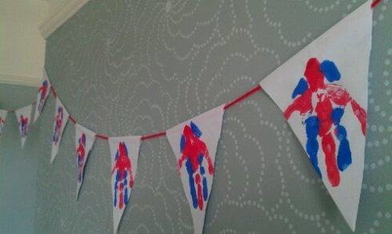

Home Learning Ideas Week 1

The Queen’s Jubilee

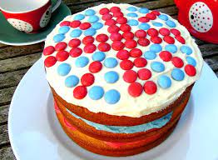

In Maths we will be preparing for our special tea party this week, we will be talking about sharing fairly, dividing our biscuits so we have half each.

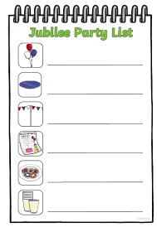

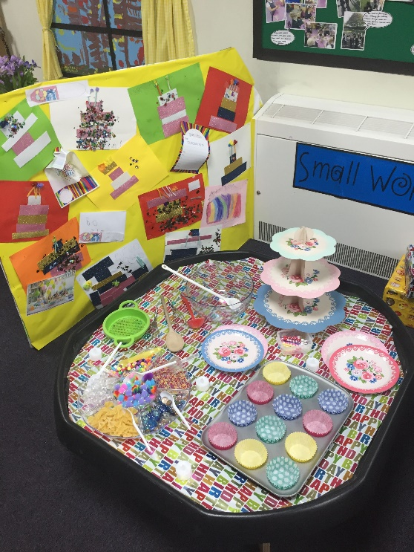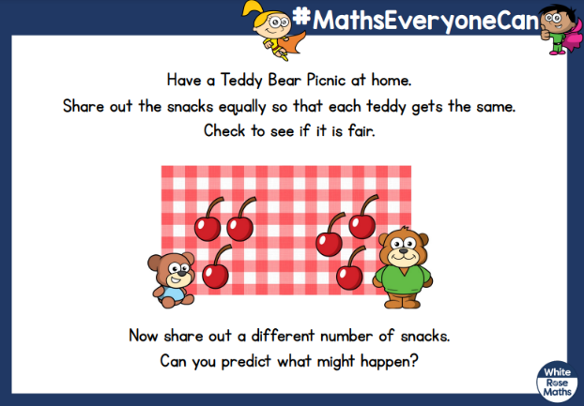

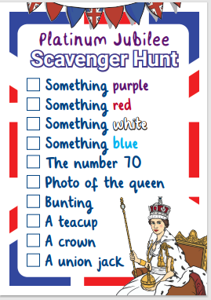

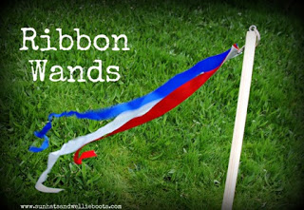

We will start the term by reading a book about the Queen’s life. We will also look at non fiction articles from newspapers.

This week we will be playing lots of games in the garden, e.g. scavenger hunts, croquet, ribbon dancing.

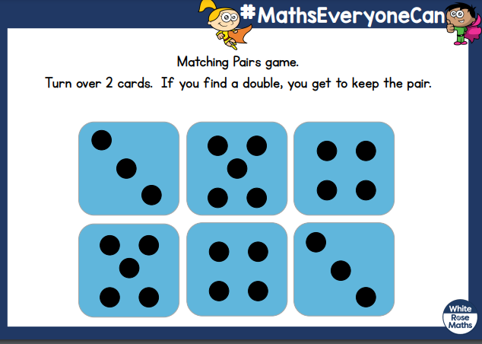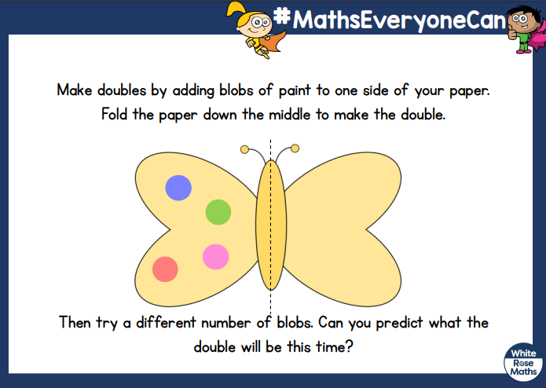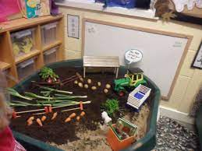

Speech Development Day-

This week we will be thinking about “Where in the world have we seen the Queen?” We will spotting her on coins, stamps etc. and learning about the commonwealth.

This week in maths we will be talking about doubling and adding more. We will be noticing when someone has the same quantity as us. We will be showing this as a numbers but also as patterns with spots and objects.

.

Home Learning Ideas Week 2

**Where in the world can we find the queen?**

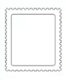

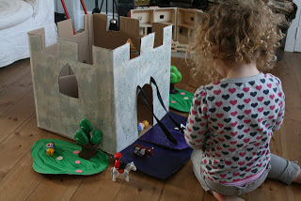

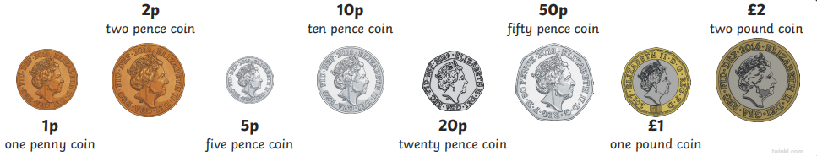

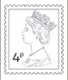

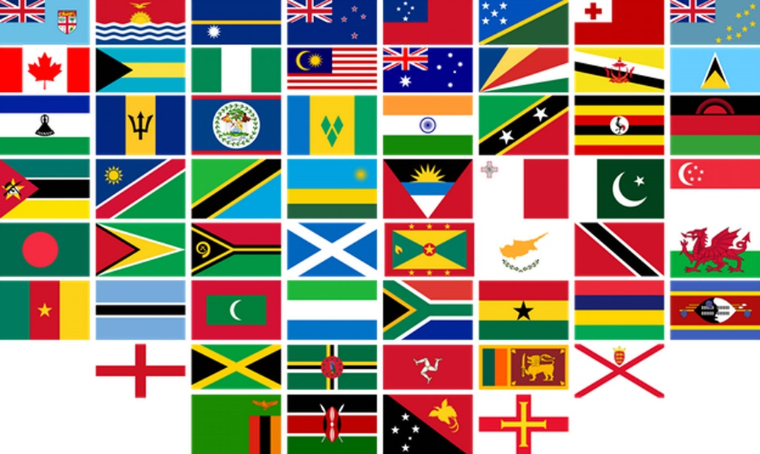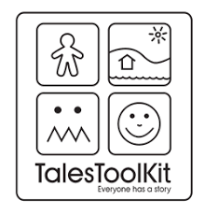

Our science will look at where do we live? Where does the Queen live? How are our homes different to animal habitats? We will look at homes in other commonwealth countries.

This week we will be making our own stories up about the queen, thinking carefully about the different settings and places she might visit.

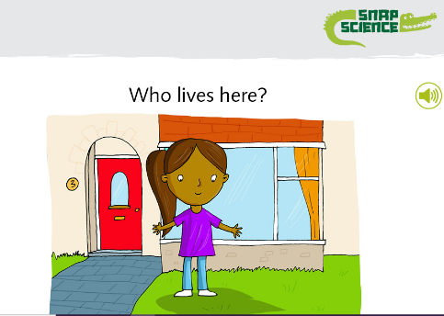

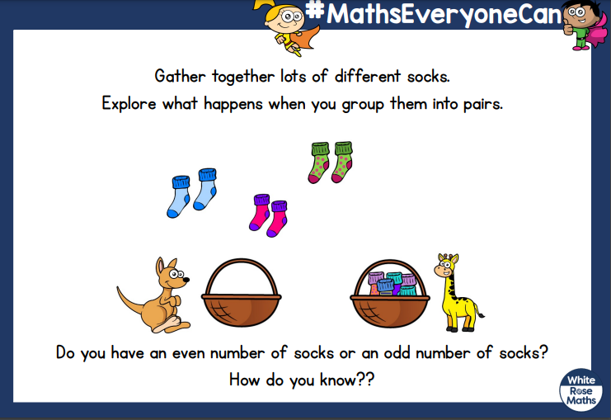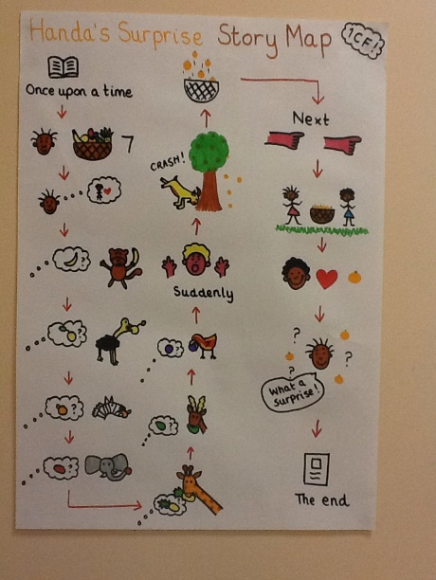

Drawing and mark making- This week we will be drawing story maps to help us retell the story.

This week we will be reading the story of Handa’s Surprise. We will be comparing homes, food, and different ways of life.

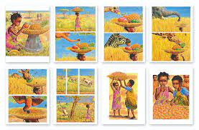

Home Learning Ideas Week 3

South Africa/ Handa’s Surprise



Number and counting- This week will be sorting objects into groups, matching objects into pairs, finding groups of two and knowing when there is an odd one left.

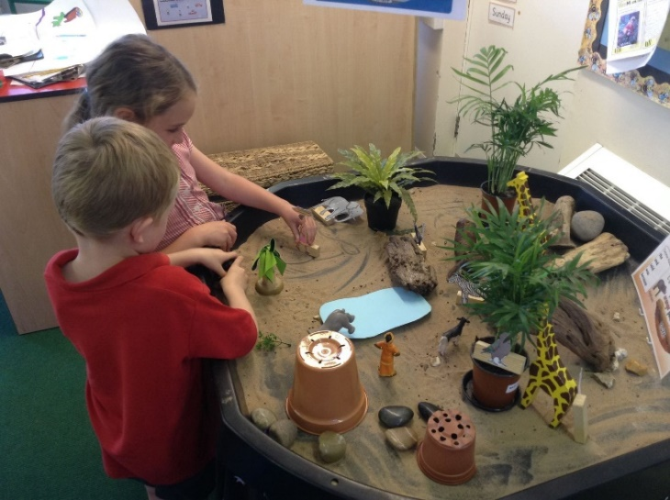

Reading, listening and re-telling- This week we will be focusing on reading both fiction and non-fiction books. We are going to be thinking about finding out facts as well as learning the story of Handa.

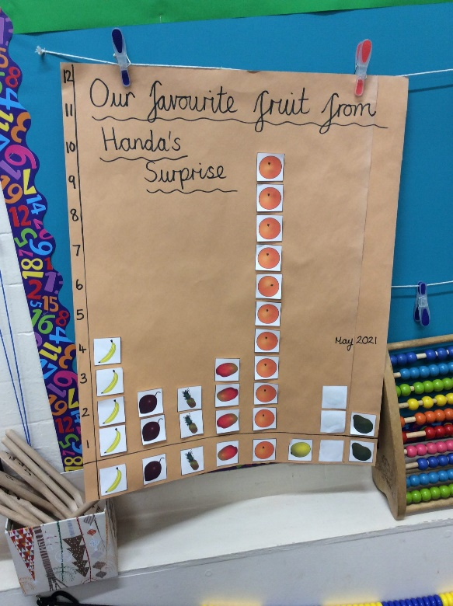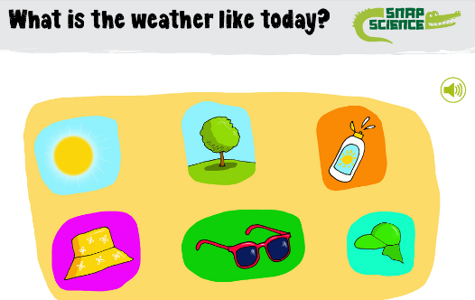

This week we will be tasting the different fruits from the story and deciding which was the most popular fruit.

Understanding the world- We will be asking questions like… What is the weather like in England? What is the weather like in Luo, South West Kenya? What do we need when the weather is hot? How do we protect our bodies?

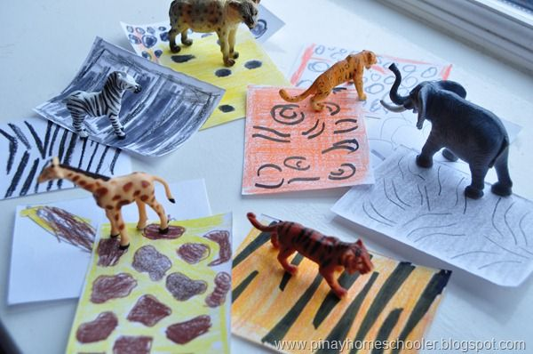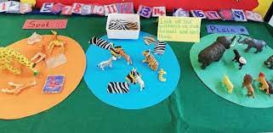

We will be sorting animals in many ways e.g. looking closely at how they move, or their patterns

This is our second week of Handa’s Surprise. We will continue retelling the story using story props, small world play, fruit, pictures to sequence etc. This week our Reception children will be creating their own stories, changing the story line, introducing alternative fruits or animals.

Home Learning Ideas Week 4

Handa’s Surprise



This week will focus on the creative parts of the story, patterns of animals, fabrics or fruit. Sounds that could be heard in the village from African instruments or animals.



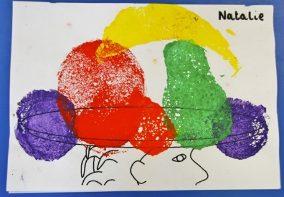

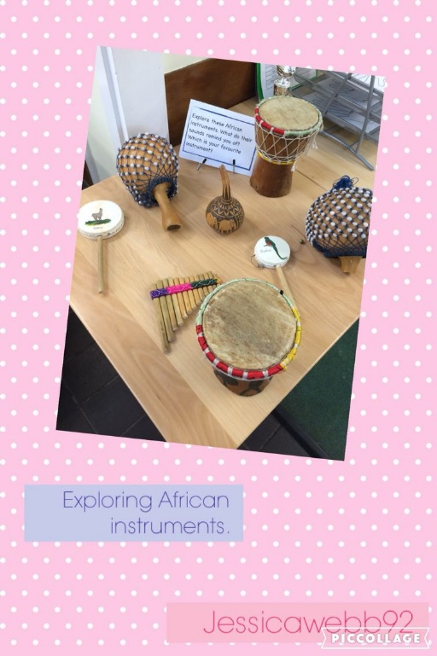

Maths stories- This week we will be drawing maps, both of our story and of the school. We will be using the language of first, then, now. We will describe the journeys that our characters go on, or use the map to direct someone to discover some treasure.

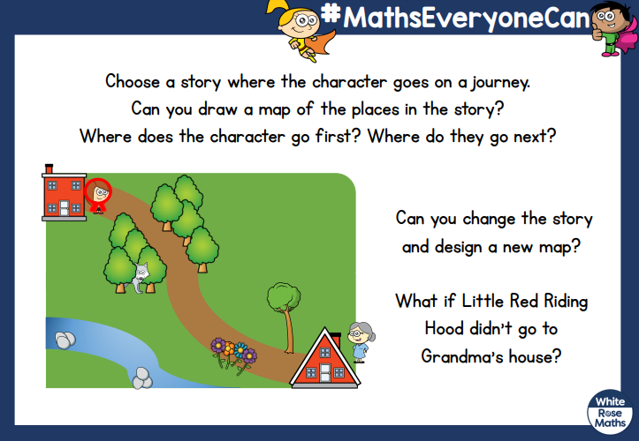

This week in science we will be continuing to look at the changing weather. We will look at the clothes worn in the UK, compared with other places in the world.

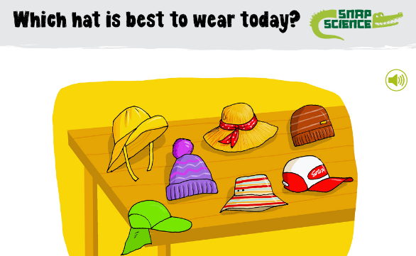

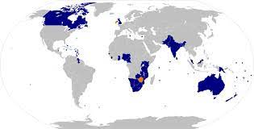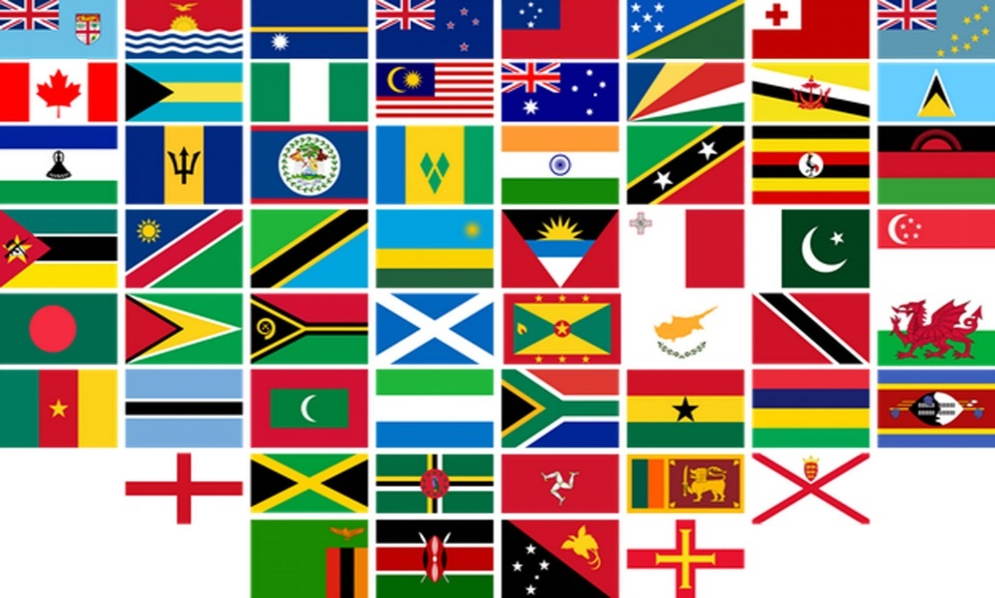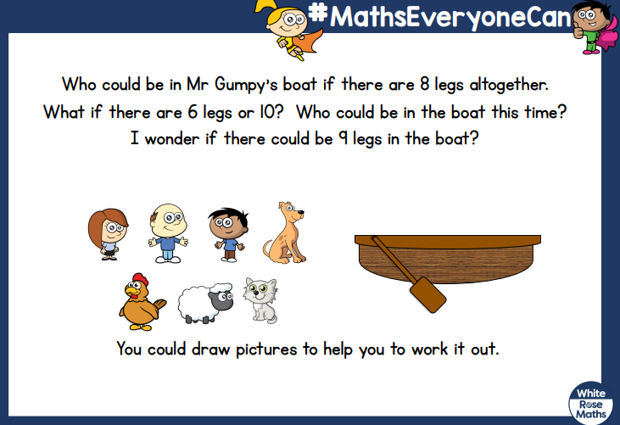

Home Learning Ideas Week 5

How does the Queen travel?/ Cold country comparison/ Canada

This week we will turn to the other countries that the Queen has visited and how she would have travelled there. We will be thinking about travelling to colder countries and compare them to the location of Handa’s village.

Number and counting- Over the next week we will be playing games that involve problem solving. Talking about journeys, how many people fit on the bus? How many legs in total?

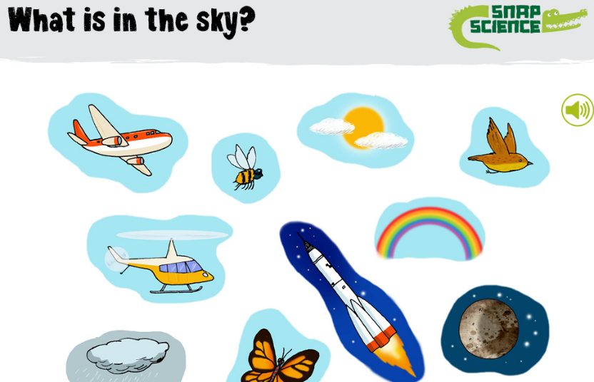

As the end of term nears, we will focus on transition, ensuring lots of opportunities to meet our new teachers and work in our classroom for the following year. We will look at how much we have changed and grown over the last year. We will revisit some of the activities we did in the Autumn term and notice the changes in ourselves and our environment.

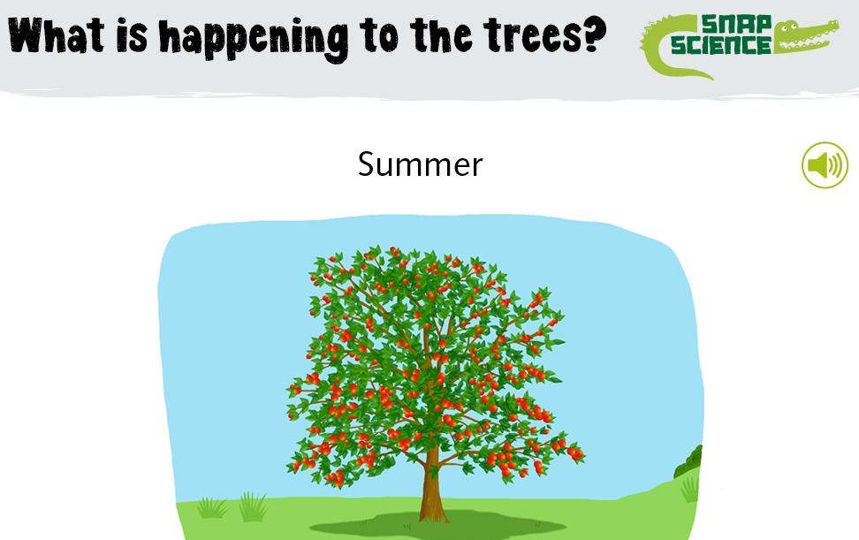

We will be considering all the things that are in our skies. What naturally flies and what is a manmade form of air travel.



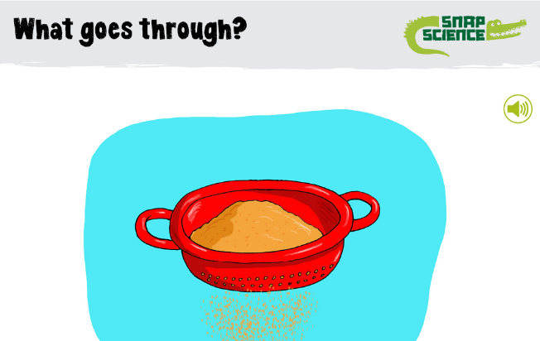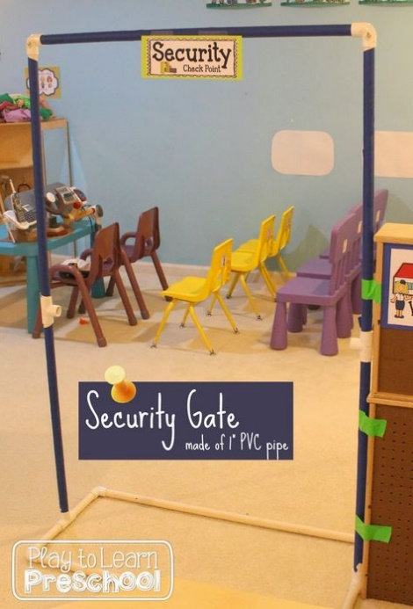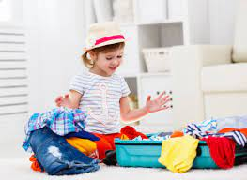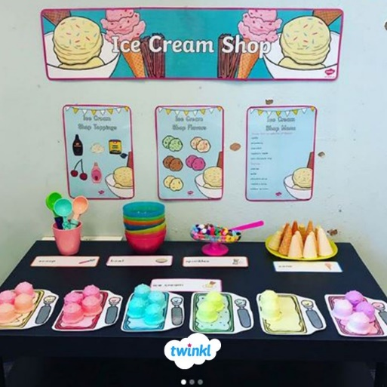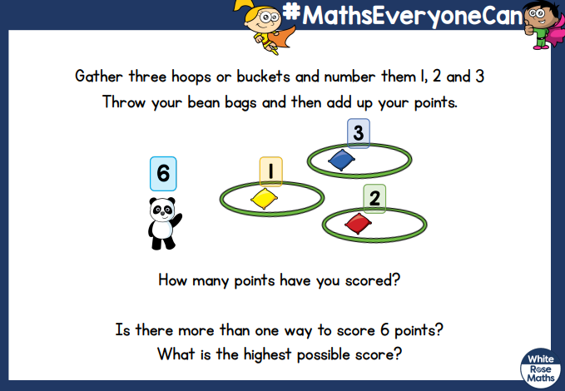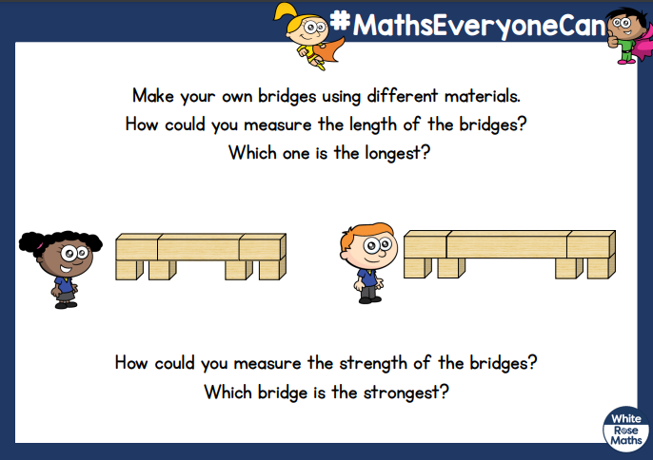

Home Learning Ideas Week 6 &7

Holidays/ Transition

In our last week and a half of term we will focus on holidays, sun and water safety,

We will think about the best bits of the year in our current classes and allow the children to plan for their last week with us in Early Years. We will repeat their favourite activities and events.

This week we will be doing lots of sand investigations linked to visiting the seaside, using sieves to separate sand, shells and stones.

We will be exploring holidays through role-play area’s e.g. airports, packing suitcases, ice cream shops.

We will be continuing to think about problem solving in maths both inside and out, scoring games, and problems linked to measurements.