Principal: Mrs B Trotman
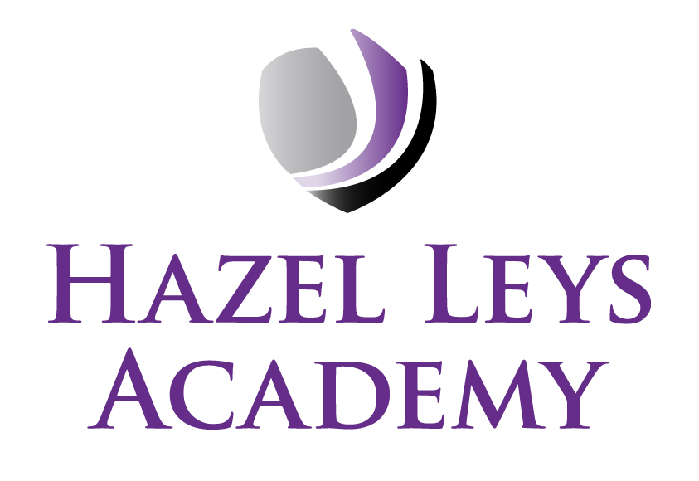
Assistant Principal: Miss K Wareing
Assistant Principal: Miss M Celebicanin
Gainsborough Road, Corby, Northants NN18 0QF
Telephone: 01536 202681
Email: admin@hazelleysacademy.org
Website: www.hazelleysacademy.org

15th September 2026

Year 3 Trip to The Fitzwilliam Museum, Cambridge – Tuesday 24th November 2026

Dear Parent/Carer,
We have organised a fantastic trip to The Fitzwilliam Museum, for our Year 3 children on Tuesday 24th November 2026. This trip will enhance the learning that has taken place in the classroom to increase their knowledge of art in still life/form.

The trip will take place during school hours. The coach will leave at 9.00am and we expect the coach to return to school by 3.15pm. Please ensure your child arrives to school at normal time. Your child must be wearing their school uniform. If you have ordered a hot dinner through Kingswood Catering, please change the option to a packed lunch or send a packed lunch from home. All children must bring a water bottle.

The cost of this trip will be £9.00; this includes travel costs, insurance and the entrance fee in total.
Whilst payments are voluntary, if not enough contributions are received we reserve the right to
cancel the trip.

We have added this trip, including the consent form, to your child’s ParentPay account. We have
listened to Parent/Carer feedback and have created an installment plan for this trip, splitting the
overall cost into 2 payments, however the full payment must be received by Saturday October 31st 2026.

If you could please complete the online consent and, where possible, pay the requested voluntary
contributions. If you need help logging onto your ParentPay account, please contact the school
office.

Many thanks for your continued support.

Yours sincerely
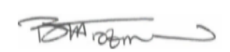

Beverley Trotman
Principal

