Principal: Mrs B Trotman
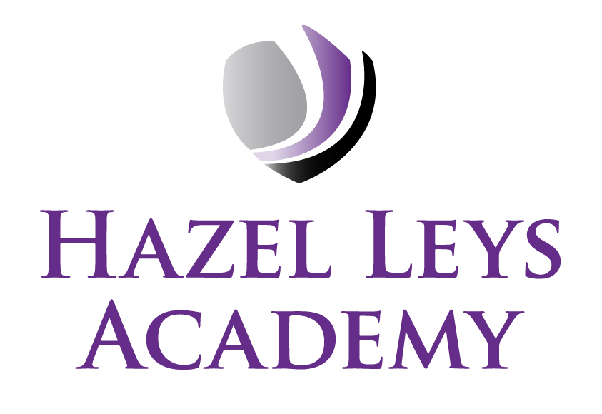
Assistant Principal: Miss K Wareing
Assistant Principal: Miss M Celebicanin
Gainsborough Road, Corby, Northants NN18 0QF
Telephone: 01536 202681
Email: admin@hazelleysacademy.org
Website: www.hazelleysacademy.org

15th September 2026

Year 6 visit to Hazard Alley, Milton Keynes – Thursday 5th November 2026

Dear Parent/career,

As a part of keeping children safe in education, we would like to take the Year 6 children to 'Hazard Alley'
in Milton Keynes to investigate real life hazards around us, including fire safety.

This visit will encourage the children to identify everyday hazards and develop safe strategies to deal with potential emergencies, helping them to keep themselves and others safe. If there is any reason why your child may become distressed when working through emergency situations, such as a house fire or
road accidents, please ensure you talk to your child’s class teacher about this.

The trip will take place on Thursday 5th November; we will leave school at 8.35am. Children need to
arrive at school at 8.25am with a packed lunch. If you have ordered a hot dinner through Kingswood
Catering, please change the option to a packed lunch or send your child with a packed lunch from home
in a plastic bag. Our return time will be 3.00pm just before the end of the school day.

The cost of the visit will be £30.00; this includes travel costs, insurance and the entrance fee in total. The school has already contributed towards the overall cost to bring down the cost for parents/carers. Whilst
payments are voluntary, if not enough people contribute we reserve the right to cancel the trip. Visits
out of school are of great educational benefit for your children and we appreciate your support with
them.

We have listened to Parent/Carer feedback and have created an installment plan for this trip, splitting the
overall cost into 2 payments, however the full payment must be received by Saturday October 31st 2026.

All children should wear their full school uniform with shoes or trainers for comfort due to some of the
activities that will take place. We have added this trip, including the consent form, to your child’s
ParentPay account. Please make your payment and complete the online permission form by Saturday 31st
October 2026. If you need help logging onto your ParentPay account, please contact the school office.

Many thanks for your continued support.

Yours sincerely
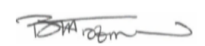

Beverley Trotman
Principal

