
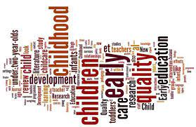
The Early Years Foundation Stage
At
Hazel Leys Academy
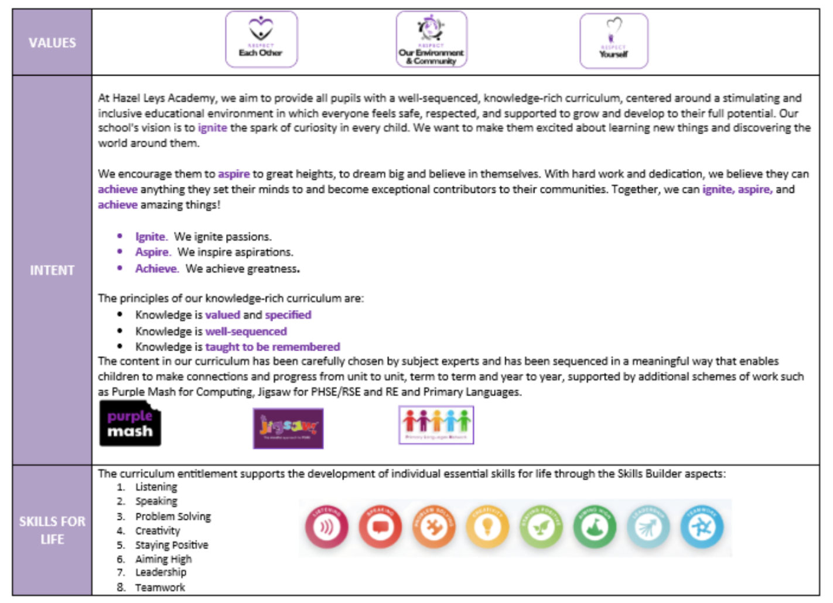
Hazel Leys Academy Curriculum Intent
Overview
Across our Early Years at Hazel Leys Academy, we cherish childhood and want all children to be happy, to enjoy school and love their learning. We strive to create an engaging and practical learning environment that fulfils all areas of the Early Years Foundation Stage, where children can learn through their interests and develop the skills that will help them in school and beyond! Our shared values will guide children in their decision making and underpin their moral development in school. At Hazel Leys we believe a knowledge-rich curriculum provides children with the best understanding of the world around them and know their place in it.

Learning will be fun and early years practitioners will create opportunities to challenge and further develop learning through continuous provision. As many of our activities as possible are play-based, however there is also a need for some direct teacher-led activities to ensure all children gain essential knowledge and skills. When appropriate, activities are expertly modelled, and priority is given to providing sufficient sustained periods of play with support and resources to allow children to repeat and practice their taught skill development.
Intent

Our provision will provide all children with the same experiences and give them opportunities to take part in learning that they may not have access to outside of school. We center our curriculum around building vocabulary and have expectations that children answer using full sentences, including the use of STEM in Maths. We build upon prior vocabulary and extend children’s knowledge of concepts through high quality texts, modelling language and having high expectations for how the children use talk in the classroom. Fine motor is an equally important part of our provision to develop the children’s hand/finger strength. Using dough disco, get squiggling, and daily fine motor practice as well, the staff ensure that children build strong fine motor skills to support with early writing. The early years staff know the importance that physical development has on many areas of children’s learning.

We are passionate about developing a love of reading from the very start of our pupils’ education: through our library visits, reading for pleasure stories and phonically matched reading books in Reception, reading opens the door to the world of adventure, increasing imagination and curiosity. We also have a book led thematic learning which feeds down into the wider provision so that the children are emersed in stories.

We highly value the importance of our outdoor environment and believe that it offers children a unique opportunity to develop a wider range of skills than simply accessing an indoor environment. The outdoor classroom is a safe environment for children to take risks, build collaborative relationships, extend their imaginations and observe changes to the natural world. Underpinning all of our indoor and outdoor provision are the Characteristics of Effective Learning where children are given opportunities to play, explore, focus, set personal challenges and think critically about their learning. Staff know that these are all essential learning behaviours that provide children with valuable life skills they will use continually. Learning will be further enriched through visits within the local community and beyond!

We believe the adults at school and at home play a vital role in shaping the whole child as both pupil and a person, and we value our children and families, creating a triangle of trust between practitioners, parent and child. To build strong partnership with parents, we will have an open-door policy, parent sessions where they can join in with their children’s lesson, sessions where children can share their work with their adults and ‘wow’ moments where parents can share the amazing thigs their children do at home. At Hazel Leys we also use Evidence Me to share our learning with parents.

In order for the EYFS staff to ensure that the approach to the curriculum is collaborative and reflective of the ever-changing needs of each cohort, we have CPD meetings where all staff contribute to the curriculum development at Hazel Leys.
Implementation
Environment
We know that each cohort of children has different needs, so we ensure that the provision is reflective of this. Using our baseline, we focus on what the children need and want in order to support their learning. We aim to give children experiences that they might not get outside of a classroom setting, such as setting up engaging role play areas and modelling how these should be used, working with children to extend and challenge them with their understanding of the wider world through the use of adult questioning. The provision is planned by adults with opportunities for child led interests which can be seen in the moment when adults respond to the children’s interests, but the children have the lead role in what and how they want to learn.

Children will have access to an effective environment which contain at least the following distinct physical areas:
- Inside: creative, small world, small construction, dress-up/ roleplay, fine motor, malleable/ playdough, reading, snack area. Writing opportunities and books are embedded within all these areas to promote a love of reading and writing.
- Outside: maths, wet sand, dry sand, water, deconstructed role-play/ large construction, climbing/ gym, PE (bats, balls, stilts, hoops etc), trikes/ bikes/ scooters, nature/ science, mud kitchen, music, creative, reading, den building and gross motor mark making.

The Nursery and Reception classrooms are zoned into areas so that the learning intentions and opportunities are clear for everyone and provide the children with the opportunities to extend their learning. We equip each area with a range of open-ended resources, so the children are able to make meaningful connections and enhance each area of learning. We carefully consider how best to improve the physical, social and cognitive skills of all our children, and with particular emphasis on vocabulary and fine motor development. We want to ensure that children can fully express their thoughts and feelings orally and in writing, by the time they leave us at the end of Reception.

Outdoor provision is inclusive for all children to access every area of learning with high quality resources to promote independence and imaginative play. Throughout the year, our outdoor enhancements will represent seasonal change with autumnal resources, observation drawings, planting and bug hunting! We provide the children with suitable outdoor clothing, so they can engage with our outdoor space throughout the year, in all weathers. We believe that ‘less is more’ means that by reducing the amount of ‘stuff’ in a setting not only develops social skills such as sharing and turn taking, but also develops communication through negotiating, resilience and creativity – finding an alternative or creating a new interest completely!

We must observe how children interact with the environment and resources within, ensuring that positive interactions with practitioners support the child’s own skills and understanding, whilst being careful not to undervalue the child’s independently created play or child-initiated learning. Staff are continually reflecting on the environment and will make changes as and when they see the need to. Some activities are extended and enhanced if the children have enjoyed it whereas others will be adapted to suit the interests of the children.

The environment that the children experience should be well organised. Resources should have an obvious 'home' and adults, particularly in those early days, should model how to store them. Children generally appreciate simple, easy-to-use space and should help to create and maintain it. It should provide opportunity for children to explore using their five different senses. The children should be taught not only to be responsible for their environment, but the things they bring in from home: their 'property'; looking after things is an important skill and is also a way of developing independence.

A daily visual timetable is used in both nursery and reception to ensure time is allocated to the discrete teaching of phonics (fluency), writing (handwriting and composition), reading (decoding, prosody and comprehension), PE (fundamental movement skills) and maths where teachers and key workers will allow time to explore key interests or seasonal themes in ways that are engaging and motivating to their learners. It is important that we appreciate each child as a unique child and avoid one-size fits all teaching. We believe that staff should not place a ceiling on the children and expect them to complete pre-determined or differentiated tasks. All tasks in EYFS are open-ended and are supported through scaffolding where the staff are the facilitators so that all children can achieve their potential.

Adults
In Nursery, staff will support the children’s development in all areas of learning. As the children settle into Nursery, staff will take the time to form meaningful relationships with the children and the parents, as next steps are carefully planned to ensure teachable moments through meaningful interactions and experiences. The Nursery Lead Practitioner is responsible for planning activities that provide children with purposeful learning that links to the thematic focus for each term.

In Reception, the teacher/teaching assistants will act as key people for all the children in the class and through meaning learning observation and interactions with each child, create a unique picture of each child. This will be used to inform all adults within the setting of each child’s current stage of development across all areas of learning and appropriate next steps and/or areas of support or intervention required. The teacher must also ensure all adults in the environment are aware of each child’s most important next step(s).

Early Reading and Phonics
At Hazel Leys we use the Little Wandle Letter and Sounds Revised programme to ensure high quality, consistent teaching of phonics and early reading for every child. In nursery, the children take part in daily phonic sessions which develop their early sound recognition skills. These sessions start in Autumn 2 to ensure children have learned the routines and expectations. Foundations for phonics ensures that children are well prepared to begin grapheme–phoneme correspondence and blending in preparation for the start of Reception. These phonic sessions include a balance of child-led and adult-led experiences. One of the most important aspects of phonics in nursery, is developing an awareness of sound, through activities that develop focused listening and attention, including oral blending.

In reception the children take part in daily phonics lessons which ensure they get the opportunity to learn grapheme-phoneme correspondences and apply them in oral blending, reading and spelling activities. We teach oral blending in every lesson in every phase as we know it remains an important part of blending words to read. When the children first start in reception, the initial phonics lessons are lively and short to support the children in learning the routines. As they used to our routines, the lessons will be extended to include learning tricky words, reading a sentence and 3X weekly guided reading sessions with a book that matches their phonological knowledge.
During the weekly reading session every child will be provided with a book which they take home at the end of the week. At the start of each reading session, staff will flash up sound cards and key vocabulary that the children will encounter in the text. Each read in school has a different focus to develop children as well-rounded readers. The first read focuses on blending skills and building up confidence with sound and word recognition. The second read focuses on prosody where children learn that they can change their voice to affect the way a text is read. The last read focuses on comprehension where the children are asked questions to develop their inference and deduction skills. To ensure that no child gets left behind, the children in reception also take part in daily keep up sessions which match the gaps in their knowledge. We aim to close that gap as soon as possible so that all children become successful early readers.
Impact
In Nursery, the long-term plan will provide a framework for consideration when planning, although practitioners should ensure that knowledge, understanding and skills are developed on the whole through each child’s interests. It is important to acknowledge that ‘Understanding the World’ may require more specific teaching and time should be set aside in the day to teach this e.g. exploring the signs of Autumn, learning about different celebrations etc.

In Reception, again, the long-term plan will provide a framework for consideration when planning, with the same consideration made to explore specific areas, particularly where they feed into Key Stage 1. Phonics, Writing and Maths will be taught in whole class groups and reading groups – LW structure - will be created to reflect each children development in word reading. Children will also take part in weekly science, History and Geography lessons which fall under the ‘Understanding the World’ aspect of our curriculum. By making children aware that they were being scientists or historians etc. they will be better prepared for the key stage 1 curriculum. PSHE, RE and music opportunities are built into the daily provision that the children can access. Direct teaching points will be delivered throughout the year, such as a week focus on Diwali, Chinese New Year and Eid.

Nursery and reception share an outdoor area, so staff have specific areas where thematic tasks are planned for ensure that learning is available inside and outside. The rest of the outdoor classroom provides open-ended activities for children of all ages. These are regularly audited and adapted by staff to meet the needs of different cohorts. All staff are responsible for knowing what the outdoor planning is for each week and are encouraged to adapt or add tasks based on seasonal events and/or children’s interest.

Throughout the year, staff will observe children formally and informally to build up a picture of each child’s needs and ability. The reception teacher and nursery lead practitioner are responsible for opening a professional dialogue with colleagues to share information and judgements on each child’s developmental achievements. Alongside this, staff also have class grids which they used for all adult directed tasks. Whilst the children are completing a task, staff record what is going well and what needs to be improved. These notes are used to inform future planning and any intervention that the staff deem necessary. A record of these grids are kept in a folder as a record of assessment.

At the end of each term, the nursery lead practitioner and reception teacher will assess children on Insight using their professional judgements. Every child will be assessed against the GAT checkpoints (for nursery) and Early Learning Goals (for reception) to track whether children are meeting or not meeting the expected standards. From there they identify areas of development and key groups of children who would benefit from additional intervention/support along with next learning steps for all. In reception, phonics will be formally assessed at the end of each half term using the Little Wandle assessment tracker. From there, keep up and more intensive 1:1 intervention will be planned for the following term. Gaps, such as tricky word knowledge can also be address through continuous provision activities in the class.

Once all data is completed staff have pupil achievement meetings with a member of SLT to talk through each child’s judgement. During these discussions staff will identify what is going well, what barriers could be affecting a child’s development and what needs to be adapted or introduced going forward. These discussions are recorded on Insight and shared with all of the SLT team.

Intervention

In Nursery, staff will, through smaller working groups, have more opportunities to support each child with required areas for development. The staff within Nursery supported by the Early Years Lead, will ensure the curriculum on offer meets the needs of the children within their key group. Termly meetings are held to allow the Nursery staff, lead practitioner and Early Years Lead to discuss progress, next steps and actions and this meeting will be used to inform future planning.

In Reception, the teacher and TA’s will engage in professional dialogue about the children’s achievement, engagement and next steps and hold weekly planning meetings to ensure needs are being met within the environment and through planned adult led sessions. Where necessary, adults will plan short intervention sessions or activities that are ‘adult led’ to support children with their next steps.
Record Keeping

In Nursery, practitioners will keep a record of each child’s work and will share this with parents, through Evidence Me, and at parents evening. The learning journey books, where a record of the children’s work is, will include original work, pictures and have the child’s voice recorded throughout. Staff also use the class grids to record how a child has completed tasks throughout the year.

In Reception, teachers will also keep up-to-date records of phonics sounds and reading progress to be shared with parents. Teachers must use observations and knowledge of progress to update planning and intervention as and when required. The children in reception also have a learning journey book where their original work, pictures and child voice are recorded. In addition to this, the Reception children have a writing book, phonics book and fine motor book to track progress throughout the year.

In both Nursery and Reception, there is no set number of observations that need to be recorded. However, it is important that teachers and key workers can speak accurately about their children’s currently level of development across all areas of learning, their key next steps and what intervention and enhancements are being used to support those next steps. Overall achievement and progress is monitored through pupil achievement meetings using the data from Insight. A record of all discussions around data are recorded in the comments box and shared with SLT.

Curriculum Overview
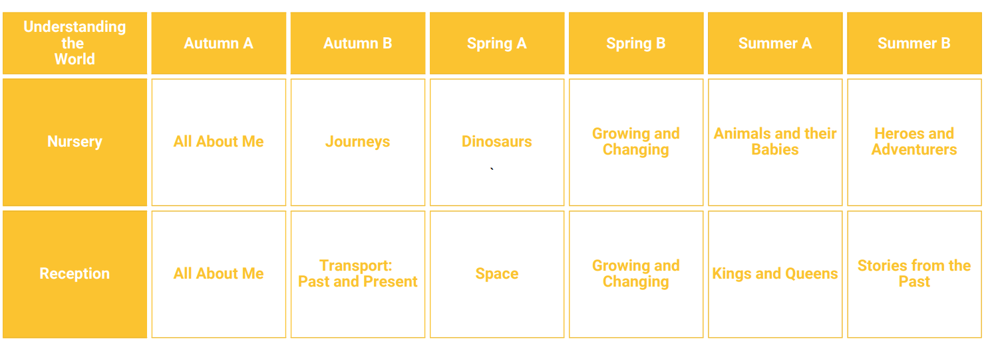
SEND – Strategies for supporting access  - Break down learning – now/then  - Adult support – start off then independent (where possible)  - Images to support  - Specific simple instructions  - Adaptive teaching  - Re-capping within lessons for all or groups of pupils  - Definitions – revisit  - Knowledge focused approach  - Objects of reference  - Widgit communication boards | Enrichment  Educational visits are another opportunity for learning to take place outside of the classroom.  - Visits from people in the community E.G Police, fire service etc.  - Trips that link to termly learning such as Space Centre, farm, castle visit.  - Children’s learning to be linked to real life experiences.  - Parents invited throughout the year to share experiences with children.

Subject Leadership and Development
Subject Strengths  - Pupil enjoyment of all lessons  - Collaborative approach to the planning – LTP/MTP with all staff  - Clear sequence of learning in planning  - Progression links between F1 and F2  - Engaging outdoor area – installed April 25  - Smooth transition for all children | Areas to Develop  - Developing model text and performances  - Development of music curriculum
Monitoring  - T1 Focus – Lesson observations, pupil voice, work scrutiny, PP focus.  - T2 Focus – Lesson observations, pupil voice, work scrutiny, SEND/EAL focus.  - T3 Focus – Lesson observations, pupil voice, work scrutiny, INT/PP focus. | CPD  - Use of EYFS Padlet created by the trust to support ongoing CPD for all staff  - Termly meetings with EYFS staff.  - Trust Conference for EY leads  - Early Years focus for whole school INSET

