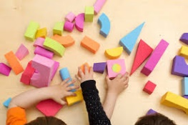
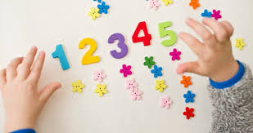
Maths in the Early Years
Thank you for joining us this morning to take part in our maths lesson. We hope that you had an enjoyable morning.
Key words/phrases that we use in our daily maths lessons and tasks:
- representation: This is how a number is shown E.G socks can show 2, a cow can show 4 (4 legs).
- subitise: Being able to recognise an amount without counting. This increases their counting fluency.
- “The last number I say, is how many I have” – This is to support accurate counting E.G 1, 2, 3, 4. The last number I said is 4, so I have 4 items.
Below are a few ideas that you can use at home to make maths fun and engaging for your child:
- Count - steps up the stairs, money into a money box etc
- Ask children to say how many without counting (5 or fewer)
- Play games using dice/dominoes and encourage child to say how many spots without counting.
- Ask children to set the table with enough knives, forks and plates for everyone.
- Spot numbers in the environment – on phones, microwaves, clocks, registration plates, doors.
- Ask children to think of their own representations for numbers eg one of them, two hands, three bears, four wheels on a car, five toes, six sides on a dice, seven dwarves, eight legs on an octopus etc
- Deliberately make mistakes. Children need to understand mistakes are normal and everyone makes them eg get mixed up when counting, muddle two numbers when ordering them.
- Hide numbers around the house or garden for children to find.
- Play outdoor maths games like hopscotch and skittles. Even better, let children make up their own games and decide how to score points.
- Read books with maths concepts eg The Very Hungry Caterpillar, One is a snail, ten is a crab, What’s the time, Mr Wolf? The doorbell rang.
- Draw attention to more and less.
Here are some websites/videos that you can use to support with maths at home:
- Cbeebies NumberBlocks episodes. This programme is written by maths specialists to model maths concepts and represents number brilliantly. Also, Numberjacks is excellent for solving problems - https://www.bbc.co.uk/cbeebies/shows/numberblocks
- Jack Hartmann subitising videos. These videos encourage children to recognise amounts without counting. – https://www.youtube.com/@JackHartmann/videos
- NRICH website. This website has maths games and puzzles that require more problem solving skills. - www.nrich.maths.org
- Shape song. A really fun way to get your child to know the names of 2D shapes. – https://www.youtube.com/watch?v=WTeqUejf3D0
- Where’s the Monkey song. A really fun way to get your child to know positional language. - https://www.youtube.com/watch?v=idJYhjGyWTU
- Let’s Count up to 10 song. A great song to help your child to be confident counting up and down to 10. - https://www.youtube.com/watch?v=6RfIKqkvHTY

